The future of Flood Action Groups in Lancashire
Scrutiny inquiry session – July 2019
For further information regarding this report, please contact
Gary Halsall
Senior Democratic Services Officer (Overview and Scrutiny)
01772 536989
gary.halsall@lancashire.gov.uk

Contents

Page No
Background and scope 2

Key lines of enquiry 2
Members, officers and Newground 3
Witnesses 4
Key findings 6
Acknowledgements 16
Glossary of terms and abbreviations 17
Websites 18
Appendix A – Who's responsible for managing flood risk? 19
Appendix B – Wyre Flood Forum governance structure 20

Background and scope

The External Scrutiny Committee at its meeting held on 16 October 2018, requested that a task and finish group be established to make recommendations on strengthening flood risk management and preparedness. From the outset of the review it was agreed that the group should hear from local Flood Action Groups (FlAGs) across Lancashire, and that a scrutiny inquiry session would provide the ideal opportunity to bring these groups together to hear their views and experiences. It was also agreed that the Newground Flood Team, part of Newground CIC (Community Interest Company) be approached to help facilitate the inquiry session.

The purpose of the session was to discuss how the County Council as the Lead Local Flood Authority (LLFA) and Risk Management Authorities (RMA) could better support and meet the needs of flooded communities in Lancashire. It aimed to provide participants with an opportunity to impart their expectations, aspirations, knowledge and experience of establishing and running a flood action group in Lancashire. The purpose was not to say who was responsible for what. Appendix A in this report sets out who's responsible for managing flood risk.

This report highlights key findings provided by representatives who attended the scrutiny inquiry session which was held on 8 July 2019.

This report reflects the views of service users, and suggestions for change will be considered but not necessarily adopted by the county council. Recommendations will be formulated by the task and finish group at a future meeting, which will form a part of the task and finish group's final report. The final report will be agreed by the External Scrutiny Committee, before being passed on to the Cabinet Member for Technical Services, Rural Affairs and Waste Management for a written response on whether the recommendations will be accepted or not or amendments and alternatives put forward. Legal and Financial advice will be sought.

References to Risk Management Authorities (RMAs) throughout this report include the county council as the Lead Local Flood Authority (LLFA).

Key lines of enquiry

Key lines of enquiry were developed and circulated to key representatives of flood action groups prior to the event being held. Specific questions were drawn up and agreed between members, officers and representatives of Newground under the following headers:

- Why was each FlAG established?
- Aspirations, expectations and support
- Knowledge and experiences
- Communication and resources
- Use of legal powers and funding

Written submissions from those people who were unable to attend the event were also accepted and received. This report has taken account of the written submissions received.

Members, officers and Newground

The following members of the Strengthening Flood Risk Management and Preparedness Task and Finish Group were in attendance:

County Councillors

- Stephen Clarke
- Nikki Hennessy
- Erica Lewis
- Eddie Pope
- Matthew Salter

Apologies for absence were received from County Councillor Cosima Towneley. In addition, County Councillor Stephen Clarke had replaced County Councillor David Foxcroft as a permanent member of the task and finish group.

The following officers from Lancashire County Council were in attendance:

- Paul Blakeley, Partnership Co-ordinator
- Rachel Crompton, Flood Risk Manager
- Heather Cummings, Business Support Officer
- Gary Halsall, Senior Democratic Services Officer
- Marcus Leigh, Highways Manager East
- Andrew Moss, Interim Head of Highways
- Dianne Taylor, Principal Flood Risk Officer
- Michael White, Highway Regulation Manager

The following officers from the Newground Flood Team helped to facilitate the inquiry session:

- Andy Ainsworth, Flood Engagement Advisor
- Lucy Crawford, Flood Engagement Officer
- Graeme Hazard, Flood Engagement Advisor
- Emma Lofthouse, Flood Engagement Officer
- Christina Worsley, Consultant

Witnesses

The following people attended the session as representatives of flood action groups/flood groups, borough councils, parish and town councils and the Lune Valley Flood Forum:

Flood action groups/flood groups:

- Kath Almond, Yarrow
- Ashley Anderton, Preesall
- Paul Barrow, South Lancaster
- Jayne Davis, Staining
- Andrew Egerton, South Lancaster
- John Gordon, Rufford
- Richard Guinness, Yarrow
- Robert Hogg, Churchtown
- Siriol Hogg, Churchtown
- Terry Jeves, Burscough
- Richard Kirkman, South Lancaster
- Kevin Newsham, Rufford
- Pamela Nickols, St Michael's
- Susan Raju, Parbold
- Linda Rowland, Preesall
- John Singleton, Staining
- Ros Wess, Parbold

Borough Councils:

- Cllr Alyson Barnes, Rossendale Borough Council
- Cllr Philip Orme, Wyre Borough Council
- Cllr Erica Lewis, Lancaster City Council

Parish and town councils:

- Cllr Neil Cookson, Pilling

Lune Valley Flood Forum:

- Janet Taylor

Apologies for absence were received from Andrew Ronnan, Whalley & Billington Flood Action Group.

Written submissions to the inquiry session were received from Andrew Egerton, South Lancaster Flood Action Group, Gavin Rattray, Burscough Flooding Group and Kath Moffatt, Priest Hutton Flood Action Group.

This report provides a summary of the issues raised and actions proposed in the course of the day's discussions. A later report from the scrutiny group will make formal recommendations to LCC.
Key findings

Why was each FlAG established?

What instigated the formation of FlAGs across Lancashire? This first key line of enquiry was fundamental to understand and appreciate the reasons why these bodies were formed in the first place and could help to identify limitations of the system, communication, education, policy and procedure; but also any misunderstandings and the perceptions of the public.

The most common reason for the establishment of these groups was in response to a flood incident and the time taken by RMAs to resolve issues. The time taken to produce Section 19 reports was also highlighted, with one group having produced their own.

Other reasons stated during the session for the establishment of a FlAG included:

- The Parish Council agreed that a residents' group be established to collect flooding evidence and produce a report for a future meeting. The Parish Council felt there was a disparity between the numbers of widespread and repeated flooding, whilst public information from the RMAs indicated a few localised problems.
- FlAG established as the area was in a known hot spot for flooding. Realised they needed a flood prevention/emergency plan.
- Fragmented reaction to repeated flooding incidents. Local County Councillor suggested the formation of a FlAG in order to get help and enable a more structured format in getting results.
- Repeated highway flooding from surface water run-off causing access and egress problems for an isolated community.
- Community surrounded by and reliant on pumped drainage systems [pumping stations] and a raised awareness and concern over the potential for flooding. Turning off the pumps was a real concern for the community.

In essence it was felt that establishing a FlAG helped to bring those who've flooded together, improve resilience whilst simultaneously providing an element of authority when dealing with RMAs in progressing action.

***

Aspirations, expectations and support

The majority of representatives reported that as individuals with singular issues it was difficult to get help or interest in forming a FlAG for their community, with only limited support being offered or gleaned from RMAs or in one case the Council for Voluntary Service (CVS). It was felt that there needed to be a mechanism to pull people together – as doing it in isolation did not work effectively. Though it was highlighted by some representatives that help along with access to officials was obtained after they had approached their local elected representative (parish, borough or county councillor) for advice and support.

Following a group's establishment most representatives reported that they had chosen to adopt a group constitution so that they could setup a bank account, apply for funding and to focus people's attention on the group's objectives. The process of generating a constitution was felt to be a useful process in that it helped people to agree the structure and operations of the group. Some groups found this process worked. However, one group reported that there were no other benefits to this process such as privileged relationships presumably with RMAs and other public bodies.

There were some unique examples whereby one group was connected to the local parish council and therefore had no need for a formal constitution. Another group had chosen not to handle its own money and had successfully approached their local parish council for reasons of audit responsibility and the capacity of the parish council to provide financial administration services. It should be noted that not all areas within Lancashire are served by parish and town councils.

For those groups who hadn't adopted a constitution it was not clear how to write one. Whilst advice to search google had been imparted, a suggestion was made to share all constitutions with the LLFA.

On what worked well for FlAGs, it was highlighted that Wyre Council's Flood Forum perhaps provided an advantage for groups within its administrative boundary by comparison with those from the rest of the County, as it enabled them to have a voice and to a degree hold the RMAs to account. The forum also provided groups with access to the Making Space for Water meetings, information and action logs and the opportunity to develop working relationships with RMAs. It was suggested that there was much to learn from the Wyre Flood Forum and that it would be useful to have similar forums or alternative options to better link FlAGs with RMAs across the county. Appendix B sets out a governance structure for the Wyre Flood Forum.

Help and support from the LLFA was acknowledged following enquiries from newly established groups. Contacting other FlAGs (neighbouring) was also found to be useful when starting out. Groups also found help and support not just from the RMAs but from organisations including; parish councils, Lancashire Police, Lancashire Fire and Rescue Service, Lancaster Area Search and Rescue, Newground, and the Lune Valley Rivers Trust.

On what didn't work well, FlAGs beyond the Wyre borough reported that whilst their initial engagement with RMAs in support of their learning journey was positive, there was a feeling thereafter of powerlessness when it came to seeing tangible actions and outcomes. Representatives felt that FlAGs should be incorporated into the decision making process and to be a part of the solution as a partner, rather than an afterthought. Furthermore, lack of action and outcomes was highlighted as a key reason for FlAGs in failing to retain active members within their groups, aside from the commitment required from members of the community in support of its activity and endeavours.

Some concerns were expressed on how a FlAG's momentum could be sustained or kept alive rather than running the risk of becoming a dormant body as the probability of repeat flooding should never be underestimated. It was suggested that in some instances groups were setup out of an individual's desire to improve their own situation and seek similar minded people to join them. However, it was pointed out that if those individuals' issues were resolved, the interest or need would no longer be there for some people to continue their involvement with such a group. Sustaining interest within communities on flood risk was also difficult for some groups.

Other groups had helped to sustain momentum through the production of a newsletter, the creation of social media groups, utilising the village online forum or having a consistent feature in their local parish council newsletter.

Some further points on what didn't work well included:

- There was lots of support for individuals immediately following a flood, but months down the line there was no support network. A sense that support from RMAs dissipates, so the group felt disenfranchised and locked out.
- One point that was shared unanimously across the groups was a lack of succession planning and a relative frequent turnover of staff across the RMAs which made maintaining relationships more difficult - notwithstanding the time taken to establish the connection and building a case (casework) in the first instance.
- Unsure who to contact for what. Passed from 'pillar to post' between the RMAs.

From the information gathered at the session it would seem that FlAGs' aspirations centred on the following aspects:

To;
- Develop an understanding of the causes of their flood risk.
- Help reduce the probability of flooding or eradicate risk(s) altogether.
- Improve education and preparedness.
- Protect their communities.
- Have better working relationships with RMAs.
- Have a voice and dialogue at Making Space for Water (MSFW) meetings.

***

Knowledge and experiences

Whilst FlAGs reported that personal contact from representatives of RMAs was good and valued and that they were content RMAs worked together within the resource constraints, their experience of RMAs working together in their areas was however questioned in relation to a few points:

- Not sharing information with each other.
- Culture - apportioning blame on each other. It was also felt by some representatives that communication and information from RMAs was obscured.
- Guarding their own patches and an unwillingness to commit to funding and timescales for action. Insist that all RMAs are open, honest and accurate in their communication and in meetings on these points. However, it was acknowledged that RMAs had different budgets with different agendas and therefore couldn't always allocate the same weighting to objectives for an area.
- A more consistent way of communicating the cost and funding sources for larger schemes needs to be applied. Concern around transparency and accountability – FlAGs had reported that they could be told differing amounts across the lifetime of a project. Although it was recognised that the figures quoted could have related to an individual RMA's contribution.
- Issues continually delayed or not a priority (longstanding).
- Not aligned to the community need for action.
- A sense that RMAs did not necessarily come across as though they worked together and perhaps worked in silo.

Though it was acknowledged that for large scale incidents big decisions were needed and progress had to be managed in an organised and strategic way which perhaps reflected in the time taken to complete such tasks.

There was a consensus amongst the groups that local knowledge was not listened to or accepted by RMAs. In addition groups felt that their work was not acted upon nor was it acknowledged. In one case a representative was told to put their qualifications on the report before it would be considered. In another instance a database and report produced independently of the group and funded by the parish council was not accepted by multiple RMAs.
Furthermore it was felt there was no pull or approach from the RMAs for such information. However, community site walkovers with the Environment Agency were felt to be an invaluable mechanism for local knowledge to be heard and considered, but also to enhance local knowledge. Such information is then compiled by the Environment Agency to form an issues and actions log. However, it's not clear how walkovers can be requested or how they are promoted by the Environment Agency or other RMA or indeed what the official name for these are.

Representatives reiterated the importance of and the need to listen to local people. Some people have lived in their communities for considerable time or even since birth and have historical knowledge that's been handed down through generations. The importance of capturing knowledge from farmers was also highlighted. Local knowledge could help to identify unknown assets such as culverts.

On understanding the remits of the different RMAs, some groups reported that this information was not clearly communicated or understood and took time to develop the knowledge required to understand roles and responsibilities. The following points were also raised:

- Similar or conflicting remits between RMAs – can be confusing for FlAGs and gives a perception that RMAs are not taking or even shirking/passing on responsibility in certain circumstances.
- Clarity needed on who's responsible for maintaining watercourses/rivers that go under highways.
- Riparian/householder responsibilities.
- No clear message about funding available from RMAs. Some areas need infrastructure investment.
- Elected members from all tiers of local authority aren't fully aware of the roles of RMAs.
- Network Rail are not an RMA. Railways can act as flood defences in West Lancashire and Network Rail are responsible for culverts but don't link in with other bodies/RMAs.

There was a suggestion that the LLFA should have a stronger leadership role. This followed comments in relation to a significant incident and a lack of cross-working and shared budgets between the RMAs leading to inaction on complex scenarios. In addition to this it was suggested that the LLFA should help in educating the public on the roles of the different RMAs. A request was also made for the county council as LLFA to set out a mission statement on its website.

A point was raised in connection with local authorities and their role as SUDS (Sustainable Drainage Systems) approval boards. This was a duty placed upon the Lead Local Flood Authority (LLFA) by Schedule 3 of the Flood and Water Management Act (2010). This part of the Act was not enacted in England. Schedule 3 was enacted in Wales in January 2019.

FlAGs experience of working with emergency services was largely positive. In some cases groups had already developed emergency plans and practised these with emergency services. Copies of their plans were also shared with emergency services. One group reported that they had established a principle that during an emergency they would not have a role to play beyond good neighbourliness and to encourage evidenced based documentation of incidents.

The following key points were also raised:

- Lack of police to close roads (not all groups reported this). Diversions also an issue. Police and LCC highways team don't allow FlAGs to put road signs out to close roads.
- One group had provided training for their flood wardens.
- When flood warnings are issued, the LLFA should provide additional support in the form of tips such as switching off your utility supplies.
- Vulnerable people need to be acknowledged and listed (database) to ensure they receive the assistance they may need if required. One example given was for those needing overnight care and for this to be provided for by the authorities. It's worth noting that British Gas, Electricity North West and United Utilities hold priority services registers, with the latter two organisations currently merging their lists.
- Preparedness from the RMAs in advance of bad weather - Knowledge that RMAs are making preparations should the worst happen in the lead up to and during events - don't wait until after an event, communicate in real time where possible.

On support and assistance for FlAGs following a flood event, concerns were raised about the perception of the group's role and blame being directed at groups. It was suggested by one group that the immediate recovery should be directed at the community irrelevant of the FlAG, but in slower time groups may become a two-way conduit for information.

Whilst most groups agreed that during an event everything worked fine, post event receiving engagement, support, information and updates from the RMAs was considered to be weak and frustrating. Emotional support was also lacking.

Other points raised on this point included:

- Vehicles kept driving through flooded roads causing bow waves to enter homes.
- A contact list of people to contact after a flood event.
- Lack of empathy and understanding from the wider community who don't flood.
- Are all district councils across Lancashire aware of flooding hotspots/areas at risk?
- A risk that flood events aren't notified to the RMAs/local officers who could link to the relevant FlAG.
- Emergency centres are often located too far away from the flooded areas and can be inaccessible if people are left in flooded areas.

***

Communication and resources

Mixed opinions and experiences were expressed in relation to communication between the county council, RMAs and flood action groups. Key points raised included:

- More communication on successes by the LLFA, RMAs and FlAGs. This would help groups to learn, progress and function well.
- The need for FlAGs to communicate with each other.
- RMAs should generate a FlAG network for groups to share information amongst themselves.
- Utilise social media channels to engage with a younger audience and to help keep FlAGs active. Recognise that one size does not fit all – maybe some value in a central newsletter.
- Like to see more workshops where FlAGs can get together to learn from each other as well as having more opportunities to engage with RMAs.
- Responsive to easy questions, but the most critical area of communication the Making Space for Water meetings and FlAG involvement is absent or in some cases short lived and specific to a single flood event.
- FlAGs can also help circulate useful and positive information into the public domain. Parish newsletters are another communication channel.
- FlAGs should be kept better up to date with Section 19 reports produced by the LLFA.
- Increased communication with landowners including farmers would be useful.

Some groups were clear on the role of the county council as the LLFA. However, others were not. Further information on the role of the LLFA and other RMAs is set out in the Glossary of terms and abbreviations further in this report.

On consultation by RMAs the following points were highlighted:

- If FlAGs were involved early then they would feel more connected and consulted. Genuine two way communication is required.
- FlAGs unaware of processes and the barriers faced by RMAs – can feel there is a perceived lack of action. Delays with ecology reports was highlighted as one example.
- FlAGs should have a level of technical understanding, but don't expect the general public to. Conversely there was a request for less technical language as this provided a barrier to understanding situations.
- FlAGs looking for more respect for their local knowledge. It was felt that RMAs accepting local knowledge could help unlock improved or cost effective technical solutions, quicker fixes or even carrying out additional wider work similar in concept to trench sharing.
- It was felt that RMAs consulted with Parish and Town Councils more than FlAGs and that information was not passed on to FlAGs by the Parish and Town Councils.

There was a general consensus from those in attendance at the session that the county council's flooding website was not fit for purpose beyond providing general public information and signposting. The website also lacked detail on the role and purpose of the county council as LLFA. In some cases people had never looked at the website.

Some generic search and navigational comments were made in relation to the site. However, some key factors were highlighted as pieces of information that could feature on the site to help educate FlAGs, the public and RMAs:

- The LLFA's role in relation to surface water flooding and ordinary watercourses.
- Page containing details of all FlAGs across Lancashire including links to websites, social media accounts and contact details. It should be noted that the Flood Hub website contains a page detailing community groups including FlAGs, flood schemes and events by area.
- A section on how to setup a FlAG.

It was clear from the information gathered from the session that knowledge of who to approach for a specific incident varied across the groups. In a number of cases FlAGs found themselves building their own relationships and establishing their own reporting channels such as through their local MP or through a specific contact at an RMA. Representatives also felt that where those RMAs had online reporting mechanisms, these were not satisfactory with reports logged not being acknowledged and people chasing issues due to a perceived lack of action or delay.

With regard to the LLFAs online 'Report It!' facility it was suggested that this was developed with reporting highways issues in mind rather than reporting flood incidents. The webpage merely directed visitors to either call 999 or provided telephone numbers for the LLFA and local Police non-emergency number, but no contacts for other RMAs. It was acknowledged this was not helpful for people or the Flood Risk Management Team. An interim solution had been established with the use of a team mailbox but a permanent solution was needed (the address was highways@lancashire.gov.uk however it was suggested that the Flood Risk Management Team should create their own email identity i.e. flooding@lancashire.gov.uk).

It was highlighted that riparian ownership and responsibilities were not largely understood by the public and that issues were being reported that shouldn't have been or were the responsibility of the riparian owner.

It was suggested that flooding information be provided on television screens in post offices.

The Flood Hub website was praised for its content in particular around public engagement information, insurance information and links to other related websites and services. Although some groups were unaware of this website and felt it needed to be promoted more. Conflict of opinion was expressed in relation to the level of technical detail the site should provide.

There was a general acknowledgement that FlAGs could use this resource more and that it could be developed further to include newsletters from FlAGs, potential sources of funding, the legislation that governs RMA activity and rainfall data.

The 'know your flood risk' website was highlighted as an additional resource used by one FlAG. The site was established by a former flood victim from Cumbria. In addition to this a closed facebook group for Lancashire FlAGs had been created by a former flood victim from Lancashire for the purpose of information sharing. The group as of July 2019 had 62 members.

***

Use of legal powers

Whilst differences of opinion were expressed on whether FlAGs would be prepared to accept delegated powers or responsibilities from RMAs such as the closure of roads and clearing trash screens, the majority of the representatives felt it should not be the responsibility of FlAGs to take such actions. Although some people expressed a willingness to put signs on the highway.

Key points for accepting delegated powers included:

- Opportunity to reduce the impact of bow waves from irresponsible drivers.
- People already carrying out certain roles informally – would be better to make it formal with correct authorisation.

Key points against such proposed activity:

- FlAG is too small as a group. Would need a team of people/wardens to help.
- Don't want to be prosecuted.
- Bad experience of trying to warn people of hazards. In some cases received verbal abuse.
- Health and safety issues and Police/highways clearance.

Some caveats and suggestions were raised at the session. These included:

- Signs are not adequate.
- Would need to be recognised by drivers as an official person.
- Put additional barriers on roads further in the flood zone.
- Should be people on the ground to recognise when roads need closing.
- Cleaning out trash screens on culverts is dangerous.
- Possible merit in providing people with hi-vis vests.
- Identify one or two people from the parish/borough/county council to have responsibility.

A point was made by one representative that they would be prepared on the assumption that training and insurance was provided by the RMA to undertake such tasks and that this did not remove the obligation for such activities from the RMAs who should remain responsible and accountable.

Road closures were highlighted as an issue that needed to be addressed. It was suggested that pre-identified roads for closure [and diversions] should form a part of parish council/FlAG emergency plan.

One FlAG had appointed an emergency officer who could decide when to close the road from the village. It was not clear how this power had been delegated or how this was done.

***

Funding

From the information gathered it's clear that a common reason for FlAGs not accessing funding pots was simply down to a lack of knowledge or signposting from where funds could be obtained from. For those who had pursued applications for funding they felt that there was a limited number of funding pots to apply to, due to their restricted and narrow focus.

It was felt that the LLFA should take a lead, share and facilitate a central register of funding opportunities for community projects and even provide a small amount of funding to FlAGs to cover operating costs. It was not clear whether any of the other RMAs within Lancashire provided funding. However, it was highlighted that one district Council for Voluntary Services (CVS) issued bulletins that provided an update of some funding available.

Some specific examples (besides grant funding from the government in response to severe flooding) of where funding had been received from and what it had been used for by FlAGs included:

- The Community Foundation for Lancashire – funding used to cover operating costs of meetings and publicity material.
- Churchtown FlAG had also secured funding from the Community Foundation for Lancashire. The funding was used to help provide flood warden kits in the village.
- A Parish Council had provided funding to produce publicity material to enable the FlAG to collect comprehensive independent flooding data.
- A joint collaboration between Network Rail, The Environment Agency, Parbold Flood Action Group and Vision link Ltd provided the installation of a solar assisted camera system and water level sensor to help monitor water levels remotely using smartphone technology.

A number of barriers to access funding were highlighted these included:

- Application process or business case – time consuming and challenging.
- Drawing up cost vs benefit analysis.
- Modelling of impacts.
- Drawing up flood risk assessments.
- Technical knowledge.
- Contract management skills.
- Access to and/or ownership of the land.
- Structural arrangements for shared projects and multiple funding sources.
- Not understanding 'the system'

Funding operating costs and room hire was also highlighted as an issue for FlAGs. A suggestion was also made for FlAGs to have a mechanism to contribute a local touch to funding applications for large scale projects made by RMAs.

***

A number of operational points and parochial issues were identified during the inquiry session. These were collated on to the car park message board for consideration and action accordingly by the Flood Risk Management Team.

***

Thanks are given to Newground, representatives of Flood Actions Groups/Forums, Parish, Borough and County Councillors and Lancashire County Council officers who provided information and evidence to support this inquiry session.

Glossary of terms and abbreviations

FlAG | Flood Action Group - community groups who work with the RMAs to find ways to reduce flood risk and raise awareness of flood risk to the wider community.
LLFA | Lead Local Flood Authority – LLFAs are county councils and unitary authorities. They lead in managing local flood risks (i.e. risks of flooding from surface water, ground water and ordinary (smaller) watercourses). This includes ensuring co-operation between the Risk Management Authorities (RMA) in their area.
MSFW | Making Space for Water – district/borough level meetings attended by technical officers from all RMAs to review progress with flooding hotspots in need of joint investigations, and any more significant works of joint interest.
Riparian owner | A riparian owner is someone who has any watercourse within or adjacent to any boundary of their property. Where a watercourse is sited between two or more property boundaries each owner may be equally responsible. Riparian owners are responsible for maintaining the river bed and banks within their section of the watercourse. It is their duty to work towards minimising pollution and preventing obstruction to the water flow.
RMA | Risk Management Authority i.e.  - Environment Agency  - Lead Local Flood Authority i.e. Lancashire County Council  - District/Borough Councils (x12 in Lancashire)  - Coastal protection authorities i.e. Lancaster, West Lancashire, Wyre and Fylde Councils  - Water and sewerage companies i.e. United Utilities  - Internal Drainage Boards i.e. Earby and Salterforth IDD (Internal Drainage District)  - Highways authorities i.e. Lancashire County Council
Section 19 report | A statutory duty on the LLFA to investigate flooding incidents and to publish a report identifying which risk management authorities had a function relating to the incidents, and whether those functions have been discharged yet. https://www.legislation.gov.uk/ukpga/2010/29/section/19

Websites

Lancashire County Council:

Flooding in Lancashire: https://www.lancashire.gov.uk/flooding/

Lancashire Resilience Forum: https://www.stayintheknow.co.uk/EmergencyInfo

Report it! Flooding and drainage: https://www.lancashire.gov.uk/roads-parking-and-travel/report-it/flooding-and-drainage/

Government:

Flood plan guidance for communities and groups: https://www.gov.uk/government/publications/flood-plan-guidance-for-communities-and-groups

Flood risk activities: environmental permits: https://www.gov.uk/guidance/flood-risk-activities-environmental-permits

Managing flood risk: roles and responsibilities (Local Government Association website): https://www.local.gov.uk/topics/severe-weather/flooding/local-flood-risk-management/managing-flood-risk-roles-and

Owning a watercourse: https://www.gov.uk/guidance/owning-a-watercourse

Other external sites:

The Flood Hub (Lancashire page): https://thefloodhub.co.uk/your-local-area/lancashire/

Know your flood risk: http://www.knowyourfloodrisk.co.uk/

NB: links provided in the report were correct at the time of publication.

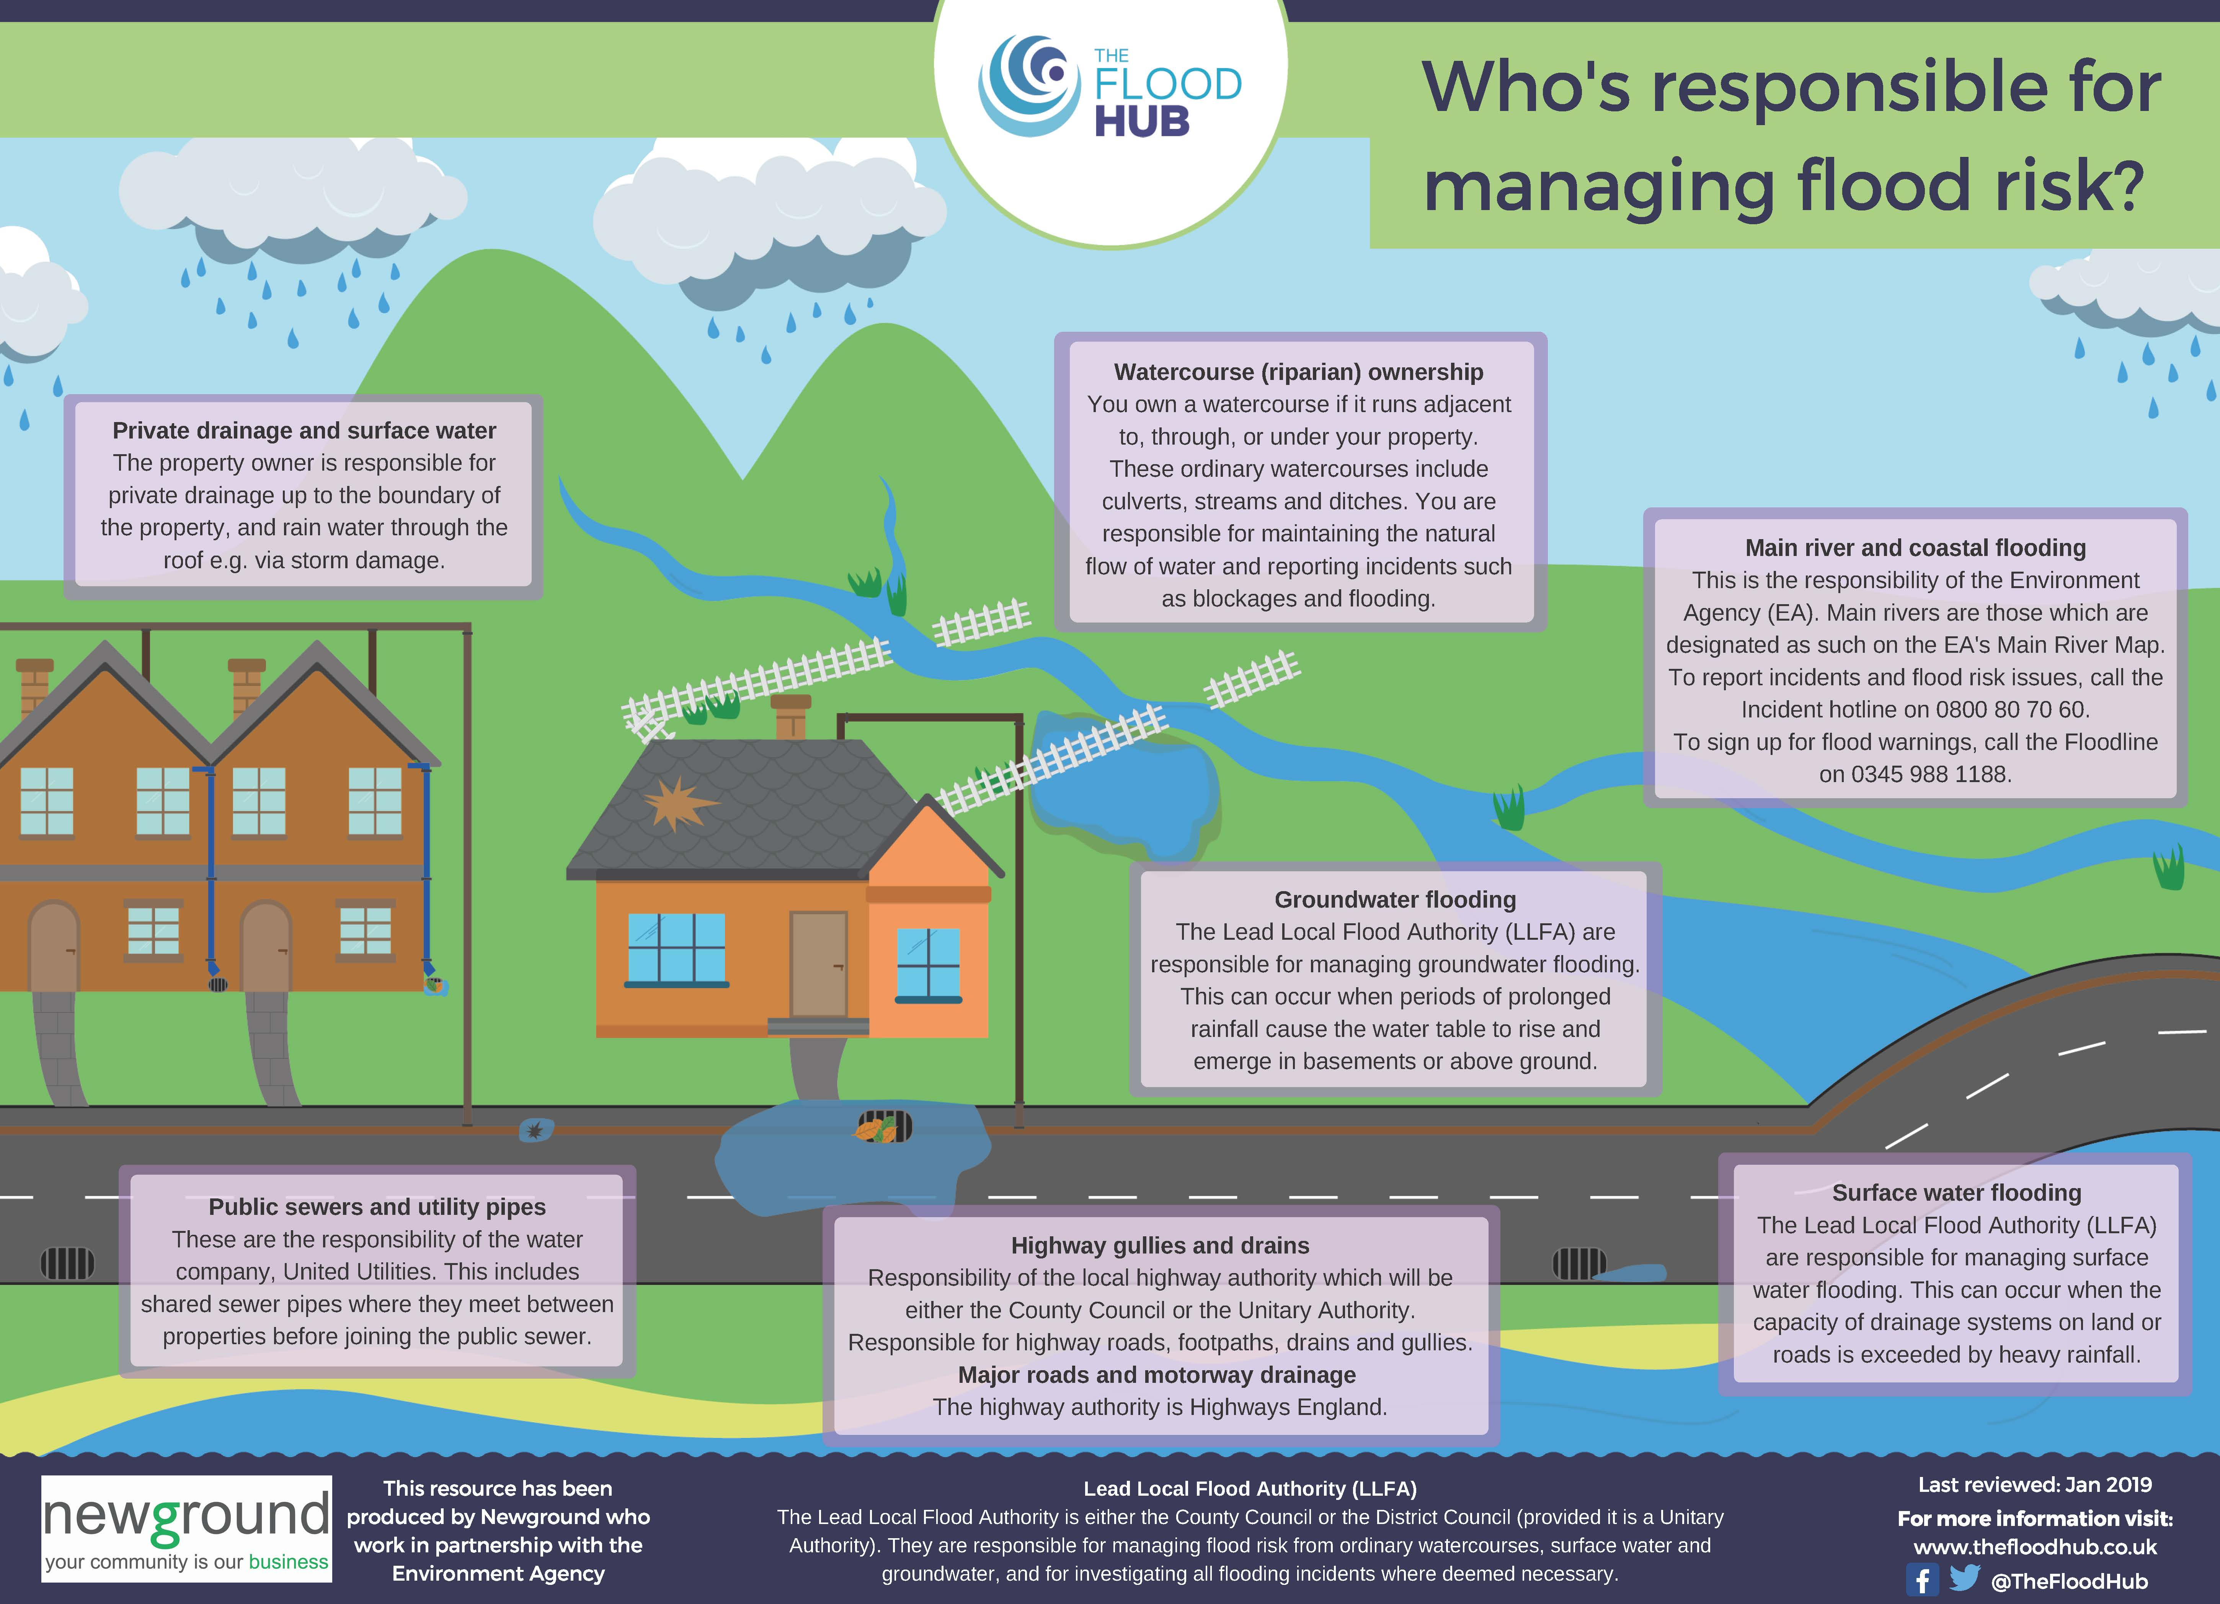
Appendix A
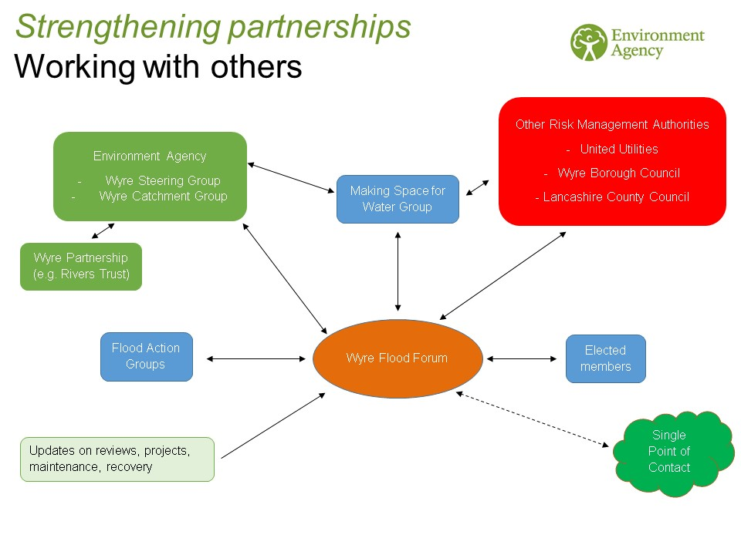
Appendix B

http://www.knowyourfloodrisk.co.uk/
https://www.facebook.com/login/?next=https%3A%2F%2Fwww.facebook.com%2Fgroups%2F786038491593051%2F
https://www.lep.co.uk/news/environment/wyre-villagers-build-their-own-flood-defences-1-9957984
https://www.vision-link.co.uk/parbold/

